North Lincolnshire Council
Daily Event Analysis
1st November 2010

Overview
The Low Santon TEOM measured a daily mean PM₁₀ concentration of 51µg/m³ on Monday 1st November 2010 exceeding the allowed 50µg/m³ as a daily mean. The Dawes Lane Coke Oven (DLCO) Osiris measured a daily PM₁₀ concentration of 45μg/m³. A check of the data has revealed that the PM₁₀ concentrations were significantly above the 50μg/m³ threshold between 14:30 and 16:45 at the Low Santon TEOM, the same period at the DLCO Osiris measured concentrations marginally above the daily objective limit. The average PM₁₀ concentration for this time period at the Low Santon TEOM was 147μg/m³. The DLCO Osiris averaged at 45μg/m³.

Met Conditions
Winds ranged between 180° & 10°. The wind within the 2 hour & 15 min period of focus ranged between 202° and 228°. Wind speeds averaged at 2.8 m/s. Heavy rain was observed in the evening after 19:00.

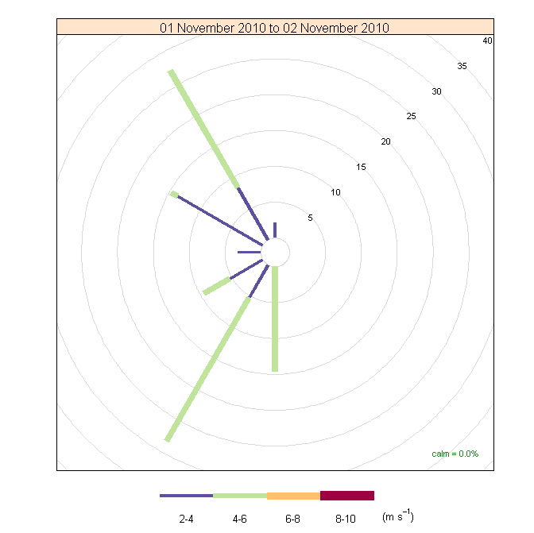

Episode Wind Range

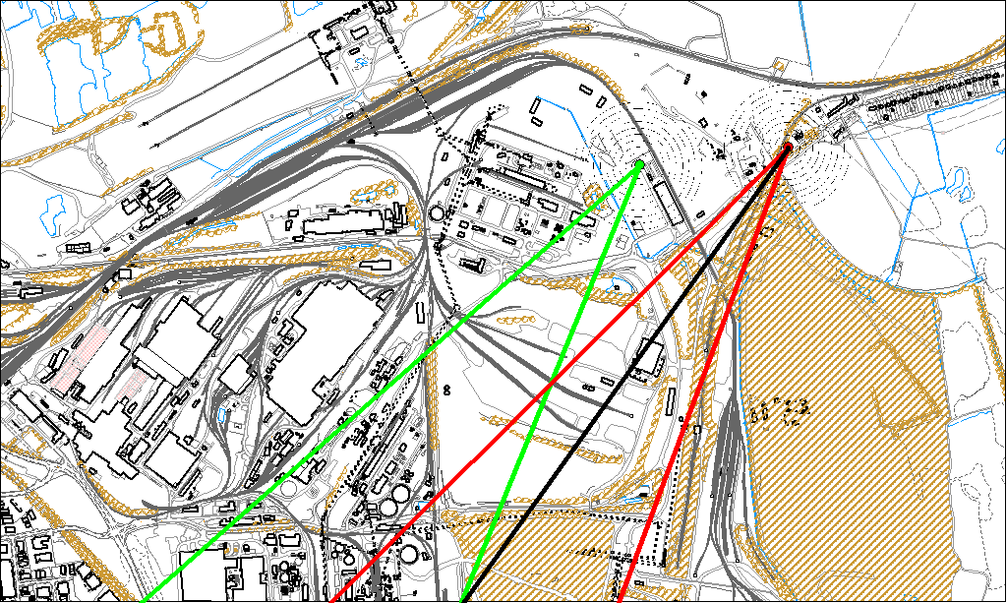

Potential Sources
The above map shows the Low Santon TEOM (indicated by the red lines) and the DLCO Osiris (indicated by the green). The black line within the red shows the wind direction of the highest concentration recorded during the 2 hour and 15 min period of focus.

As the Low Santon TEOM measured consistently higher concentrations during this period, it is likely that the TEOM was affected by a different source to the DLCO Osiris. Therefore, the areas in which the red and green lines intersect are unlikely to be the location of the problem.

The likely areas include;

- Redbourn Site
- Slag Haul Road
- Intermediate Site

The black line indicates the highest measured concentration of 212μg/m³ recorded at the Low Santon TEOM during this period. It runs along the Slag Haul Road, Redbourn Site and the Intermediate Site.

